Monitoring of the construction of priority section of the Bar-Boljare highway
(Smokovac - Mateševo section)
2019/2020

(NON) WORK OF THE Environmental INSPECTION IN RELATION TO THE HIGHWAY PROJECT
Analysis of the actions of state institutions

The study is a part of the project "Active citizens for Montenegro - towards the rule of law and sustainable development of Montenegro" funded by the European Union through the Delegation of the European Union to Montenegro, and implemented by the NGO Network for Affirmation of NGO Sector - MANS. The opinions and views taken herein shall not in any case be considered as those of the donors that financially supported the project.
CASE STUDY

(Non) work of the Department for Environmental Inspection in relation to the project of construction of the Bar - Boljare highway

Bearing in mind that it was not possible to obtain data on what and in what way the inspections within the Directorate for Inspection Affairs of Montenegro did in connection with the devastation of the Tara River, which was processed in a special study, in June 2019, MANS tried to obtain broader data on the work of the Department for Environmental Inspection.

MANS then asked the umbrella inspection institution for information on:
In December 2014, the Parliament of Montenegro adopted the Law on Bar - Boljare Highway, thus creating a legal precondition for starting the "project of the century" in Montenegro, as the highway is often called.

Previously, in February that year, the Government of Montenegro concluded the Contract on design and construction of the Bar - Boljare highway, section Smokovac - Uvač - Mateševo, with the Chinese company "China Road and Bridge Corporation" (CRBC). Value of the works is estimated at €809 million, and the financial construction was completed by signing a preferential loan agreement with the Chinese EXIM Bank in October 2014, according to which the Chinese bank will provide 85% of the funds needed for construction, and Montenegro 15%.

The works on the construction of the highway officially started in May 2015, and in addition to the main contractor, the company CRBC, the largest domestic construction companies were also hired according to the contract. The construction of the highway in Montenegro has been the subject of numerous controversies from the very beginning, while the lack of transparency regarding this project has been the subject of a report by the European Commission on the process of Montenegro's accession to the European Union.

- the total number of conducted inspections of the construction site of the Bar - Boljare highway by the Department for Environmental Inspection
- the total number of fines imposed by the Department
- the total amount of money in which the fines were imposed.

In its response, after ten days, the Directorate for Inspection Affairs provided MANS with the following information:

- a total of 68 controls were conducted by the Department for Environmental Inspection
- two fines were imposed - of €3,000 and €3,500
- 17 requests for initiating misdemeanour proceedings were submitted to the competent courts.

Photo 1: Part of the decision of the Directorate for Inspection Affairs, which refers to actions of the misdemeanour courts after the requests sent by the Department for Environmental Inspection
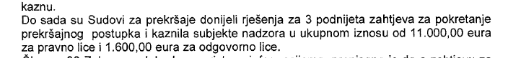

Let us note that this is a four-year period, since the construction of the priority section of the highway began in May 2015. On average, the Department for Environmental Inspection visited the highway construction site 17 times a year.

For the sake of comparison, according to the data of the Directorate for Inspection Affairs in the period from 2015 to 2019, the Department for Environmental Inspection performed 9242 inspections.

These data indicate that the environmental inspection, headed by Veselinka Zarubica - Chief Environmental Inspector, visited the highway construction site one out of 136 times, or that the share of supervision over the said construction site represents only 0.74% of the total environmental inspection in Montenegro.

This data becomes especially problematic if taken into account that this is the largest and most expensive project built in Montenegro so far, which especially endangers the habitat and environment of the Tara River, protected both nationally and internationally. In addition, the construction site of the highway directly leans on the Morača River, and indirectly affects its entire surroundings, since there are camps for workers and landfills for the disposal of surplus materials.

In four years, the environmental inspection sent 200 requests to the courts to initiate misdemeanour proceedings, of which only 17 related to irregularities in performing of works on the highway project. Data on the two fines imposed, of €3,000 and €3,500, are unknown to the public, because it has not been announced who was fined by the environmental inspection in the mentioned amounts and what for.

On the other hand, after discovery of devastation of the Tara River at the end of October 2018, NGO MANS sent an initiative to the environmental inspection to conduct an inspection, in which it was noted that the riverbed was largely devastated, that the land was damaged and destroyed, with endangered flora and fauna of the river.

In her answer from November 30, 2018, Inspector Zarubica states that the environmental inspection has been carrying out intensified inspection supervision of works since the beginning of the project implementation, which is denied by the previously listed data.

Photo 2: Part of the response of the Department for Environmental Inspection upon the initiative of MANS
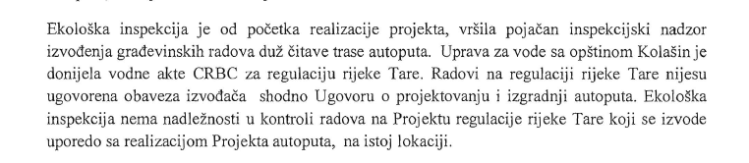

Later in the document, the environmental inspector states that the research on the state of biodiversity in the aquatic ecosystem of the Tara River from 2017 and 2018 determined that "species diversity is directly or indirectly affected by construction works", and that a smaller number of fish in the length of 10 km is a consequence of the presence of suspended matter along the river flow.

However, in the opinion of the "research team", it is stated that "deteriorated water quality will improve and reach almost complete natural values in few years after the cessation of construction activities."

It is clear from the received document that the inspection dealt exclusively with the consequences and plans for remediation of the devastated area, but not with the responsibility and possible omissions, which practically released the contractor - Chinese company "China Road and Bridge Corporation" of responsibility.

Photo 3: Part of the response of the Department for Environmental Inspection upon the initiative of MANS
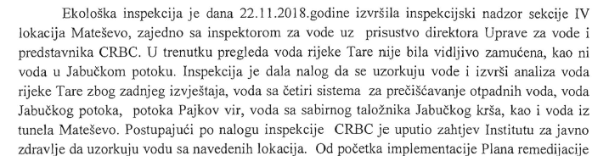

From all the above, it can be clearly concluded that the environmental inspection does not intend to address the responsibility of the contractor for the damage it causes every day to one of the most valuable resources of Montenegro – Tara River, as well as that the inspection's attitude is generally inadequate towards the most expensive project ever built in Montenegro, which can have far-reaching consequences for the valuable natural resources that Montenegro has.

See more at: http://www.mans.co.me/studija-slucaja-inspekcija-sakrila-informacije-o-nadzoru-radova-na-rijeci-tari/
Request for free access to information NGO MANS no. 128080 of 3 June, 2019
Decision of the Directorate for Inspection Affairs no. 0801-03/2019-39/2 of 13 June, 2019
Reports on the work of the Directorate for Inspection Affairs for 2015, 2016, 2017 and 2018
See more at: http://www.uip.gov.me/inspekcije/opis_ekoloska
More information can be found at: http://barboljare.me/
Summarized data from the Report on the work of the Directorate for Inspection Affairs for 2015, 2016, 2017 and 2018
Initiative of the NGO MANS no. 24864/10 of 29 October 2018
Response of the Department for Ecological Inspection no. 0303/2017-8835/2 dated 30 November 2018

