Monitoring of the construction of priority section of the Bar-Boljare highway
(Smokovac - Mateševo section)
2019/2020

WORK OF THE COMMISSION FOR TECHNICAL INSPECTION OF WORKS ON THE BAR - BOLJARE HIGHWAY
Analysis of the actions of state institutions

The study is a part of the project "Active citizens for Montenegro - towards the rule of law and sustainable development of Montenegro" funded by the European Union through the Delegation of the European Union to Montenegro, and implemented by the NGO Network for Affirmation of NGO Sector - MANS. The opinions and views taken herein shall not in any case be considered as those of the donors that financially supported the project.
CASE STUDY

Work of the Commission for technical inspection of works on the Bar - Boljare highway and installation of concrete without quality assessment

State Commission for technical inspection of works on the construction of the Bar - Boljare Highway, Section Smokovac - Mateševo, was established in May 2015, after the start of works on the construction of the first section of the highway. It consists of 27 domestic experts and representatives of institutions, who coordinate technical inspection of works performed on the highway. The document establishing the commission stipulates that its work is a business secret, and that none of its members has the authority to disclose any information related to its work and competences.

The Commission, whose work is financed from the budget, sends periodic reports to the Ministry of Transport and Maritime Affairs and the Ministry of Sustainable Development and Tourism, from which MANS requested the reports according to the Law on Free Access to Information, trying to obtain all data related to the devastation of the Tara River caused by the construction of subsection 4.4.1, whose construction site rests for the most part on Tara.
In addition to the Commission for technical inspection of works on the construction on the highway, there are two more - the State Commission for audit of technical documentation and the State Commission for audit of preliminary designs for the sections Mateševo - Andrijevica and Smokovac - Farmaci.

The Commission for audit of the technical documentation of the section "Smokovac - Mateševo" was established in March 2015, it has 24 members and 0.35% of the total contracted price of € 2,833,520.74 was allocated from the capital budget of the Ministry of Transport and Maritime Affairs for their work in the form of audit of the complete technical documentation required for the construction of the highway.

The decision on the appointment of the Commission for audit of preliminary designs for the sections Mateševo - Andrijevica and Smokovac - Farmaci came into force in January 2019. The commission, which has 23 members auditing the projects of two sections of the highway that will be built next, will cost € 603,900, which is 11% of the total cost of the two preliminary projects. Funds for its work are also provided from the capital budget of the Ministry of Transport and Maritime Affairs.

The work of both commissions was declared a business secret.
However, both ministries rejected the requests, explaining such decision by the need to protect the "safety of the highway", but also by the fact that the work of the commission was declared a "business secret". However, the requested reports on the review of works on the subsection near Tara were eventually submitted by the Business Unit for the project management of the construction of the Bar Boljare highway of the company "Monteput", which is under the authority of the Ministry of Transport and Maritime Affairs.

When it comes to reports, in its analysis, MANS focused on the actions of the competent commission during control of works on facilities whose construction had a special impact on the Tara River and the area under special UNESCO protection. In this way, special attention was paid to the analysis of reports related to the works on the construction of the bridges Tara 1 and Tara 2, as well as Mateševo loop. A total of 54 reports submitted to MANS according to the Law on Free Access to Information were analysed.

The reports have shown that the construction of subsection 4.4.1 is predominantly performed by China Road and Bridge Corporation (CRBC), while in 2018, when the works began, the company Skladgradnja Split from Croatia was still performing works there, which in the meantime left the job, and CRBC took over its works. Most of the analysed documents contained the commission's findings on certain shortcomings and non-compliance with recommendations made in previous reports regarding the procedures for the construction of bridges Tara 1 and Tara 2, as well as Mateševo loop, and in only a few reports the commission stated that the works were being carried out in full compliance with the procedure.

Key objections of the Commission for technical inspection of works were:

- the projects of installed concrete and reinforcement are not shown
- the results of ongoing tests of installed materials are not presented
- tests of material did not give satisfactory results; recompression ordered
- no decisions on the selection of the chief engineer were presented
- no decisions on the selection of engineers for individual phases were presented
- geological reports are not signed by the designated person for this phase of the project.

The biggest discovery was that in September 2018, the commission concluded that "Project of the concrete and construction methodology for the construction of the Tara 2 bridge pillars has not been officially adopted - approved by the engineers/supervisors, although the works on the construction of the pillars are ongoing." Basically, this means that CRBC performed works on the construction of bridges using concrete for which they did not have an adequate quality assessment, which resulted in an investigative story of MANS, published in April 2019.

Photo 1: Part of one of the reports in which State Commission for technical inspection of works notes that construction procedures are not followed
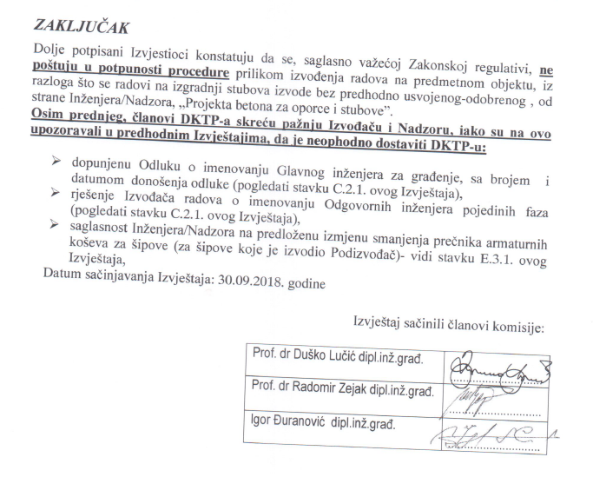
According to the rulebook of the Ministry of Sustainable Development and Tourism of Montenegro, the project of concrete construction is an integral part of the main project of the facility. It contains a technical description, calculation of load-bearing capacity and usability of the concrete structure, as well as a programme of quality control and quality assurance. The rulebook also defines that information on the origin of products/materials must be present on the construction site.

0.35% of the total contracted price for the construction of the highway, i.e. € 2,833,520.74, has been allocated for the work of the State Commission for technical inspection of works on the construction of the Bar - Boljare highway. On the other hand, it is unknown whether, and if so, to what extent CRBC was responsible for the described omissions in performing of construction works, which were obviously repeated throughout 2018.

Due to extension of the deadline for completion of works for September 2020, which will cause an increased volume of works, at the Government session held on February 13, 2020, the Commission for Technical Inspection of works on the construction of the highway was allocated an additional € 720,000, which is why the work of the Commission will for now be paid in the amount of more than € 3,500,000.

Decision on appointment of the State Commission for technical inspection of works on the construction of the Bar - Boljare Highway, priority section Smokovac - Uvač - Mateševo (Official Gazette of Montenegro No. 30/15 and 44/17)
Article 7 of the Decision on appointment of the State Commission for technical inspection of works on the construction of the Bar - Boljare Highway, priority section Smokovac - Uvač - Mateševo (Official Gazette of Montenegro No. 30/15 and 44/17)
Requests for free access to information by NGO MANS no. 125151 and 125280 of 31 October 2018
Decision of the Ministry of Sustainable Development and Tourism no. UPI 117 / 5-121 / 2 of 7 November 2018
Request for free access to information NGO MANS no. 125158 of 31 October 2018
Decision of the Business Unit for project management of the construction of the Bar - Boljare highway no. 14843 of 3 December 2018
Report of the Commission for technical inspection of works no. 03-334/18 of 3 May 2018, Reports of the State Commission for Technical Inspection of Works no. 03-93 /18 of 4 September 2018 (from the visit on 7 August 2018), report of the Commission for technical inspection of works no. 03-1370/18 of16 November 2018 (from the visit on 9 November 2018)
Report of the Commission for technical inspection of works no. 03-1163/18 of 8 October 2018 (refers to the visit on 29 September 2018)
See more at: http://www.mans.co.me/en/crbc-installs-concrete-into-the-bridges-on-the-highway-without-quality-assessment/
Rulebook on technical requirements for concrete structures (Official Gazette of Montenegro No. 020/18 of March 30, 2018)
Article 10, paragraph 2 of the Decision on appointment of the State Commission for technical inspection of works on the construction of the highway Bar-Boljare, priority section Smokovac-Uvač-Mateševo (Official Gazette of Montenegro No. 30/15 and 44/17)
Conclusion of the Government of Montenegro on the adoption of the Decision on amendments to the Decision on the appointment of the State Commission for technical inspection of works on the construction of the highway Bar - Boljare, priority section Smokovac - Uvač - Mateševo, no. 07-524 of 13 February 2020. The exact amount is € 3,553,520.74

