Monitoring of the construction of priority section of the Bar-Boljare highway
(Smokovac - Mateševo section)
2019/2020

state prosecutor's office of montenegro
Analysis of the actions of state institutions

The study is a part of the project "Active citizens for Montenegro - towards the rule of law and sustainable development of Montenegro" funded by the European Union through the Delegation of the European Union to Montenegro, and implemented by the NGO Network for Affirmation of NGO Sector - MANS. The opinions and views taken herein shall not in any case be considered as those of the donors that financially supported the project.
CASE STUDY

The actions of Montenegrin State Prosecutor's Office in the case of devastation of the internationally protected river Tara

After NGO MANS discovered in October 2018 that CRBC was permanently devastating the river during the construction of the highway in the coastal area of the Tara River near Mateševo, Municipality of Kolašin, the discovered damage to the river became a central topic in Montenegrin media.

A few days later and when it became clear that state institutions do not recognize responsibility in their ranks, or that of contractors, six NGOs filed criminal complaint against several perpetrators:
In December 2014, the Parliament of Montenegro adopted the Law on Bar - Boljare Highway, thus creating a legal precondition for starting the "project of the century" in Montenegro, as the highway is often called.

Previously, in February that year, the Government of Montenegro concluded the Contract on design and construction of the Bar - Boljare highway, section Smokovac - Uvač - Mateševo, with the Chinese company "China Road and Bridge Corporation" (CRBC). Value of the works is estimated at €809 million, and the financial construction was completed by signing a preferential loan agreement with the Chinese EXIM Bank in October 2014, according to which the Chinese bank will provide 85% of the funds needed for construction, and Montenegro 15%.

The works on the construction of the highway officially started in May 2015, and in addition to the main contractor, the company CRBC, the largest domestic construction companies were also hired according to the contract. The construction of the highway in Montenegro has been the subject of numerous controversies from the very beginning, while the lack of transparency regarding this project has been the subject of a report by the European Commission on the process of Montenegro's accession to the European Union.

- officials of the Ministry of Transport and Maritime Affairs and the Ministry of Sustainable Development and Tourism of Montenegro, due to reasonable suspicion that they committed criminal offense of Abuse of Office in prolonged period, in concurrence with criminal offenses of Environmental Pollution, Damaging the Environment and Destroying and Damaging Protected Natural Good, since by continuously failing to exercise their official authority, they enabled CRBC to relocate and change the course of the Tara River, change the river's hydrology, violating its ecological status and devastating its riverbed and coastal area,

- officials of the Directorate for Inspection Affairs and members of commissions for supervision of works on the highway, due to reasonable suspicion that they committed the criminal offense of Abuse of Office, because by failing to perform official powers in the form of inspection and supervision of works on highway construction, they enabled CRBC to displace and change the course of the river Tara, change the river's hydrology, violating its ecological status and devastating its riverbed and coastal area,

- the contractor - "CRBC" company and responsible persons in that company, due to reasonable suspicion that they committed criminal offenses of Environmental Pollution, Damaging the Environment and Destroying and Damaging Protected Natural Good since as the contractor, they relocated and changed the course of the Tara River, changed the river's hydrology thereby violating its ecological status and devastating its riverbed and coastal area.

For the criminal offense Abuse of Office, in various ranges, the perpetrator may be punished by a prison term from six months to twelve years. For the criminal offense of Environmental Pollution, a person who commits the said offense, depending on the consequences, may be punished by a prison term from one to twelve years.

On the other hand, for the criminal offense Damaging the Environment, the perpetrator may be punished by a prison term up to eight years. Anyone who commits the criminal offense of Destroying and Damaging Protected Natural Good shall be punished by a prison term from three months to five years.

In addition, the Environmental Impact Assessment Study for the construction of the Bar - Boljare highway, an umbrella document providing environmental guidelines for construction, explicitly prohibited the "disposal of excess excavated material into riverbeds, rivers, riverbanks and agricultural land."

The criminal complaint with evidence in the form of recordings and photographs was submitted to the Supreme State Prosecutor's Office on October 29, 2018. Only two days later, the Supreme State Prosecutor's Office forwarded the complaint with evidence to the Special State Prosecutor's Office, without explaining why it was doing so.

The Special State Prosecutor's Office, on the other hand, did not make any move or action in the next seven months on the basis of which it could be concluded that it was dealing with reported crimes and responsibility for them. In the meantime, the devastation on Tara is recognized by relevant international addresses, such as the European Parliament, the European Commission and UNESCO.

During that time, MANS discovers that Tara riverbed continues to be moved and relocated if necessary, that waste is continuously disposed on its banks, but also that construction procedures during construction of bridges on it are not followed. Due to the fact that in seven months and after three warning messages from important international addresses, CRBC continued to devastate the river and its area, NGO MANS filed amendment to the criminal complaint against the same actors, due to suspicion of continuous commission of these crimes.

Despite numerous public appeals during the mentioned seven months, but also later, it is unknown whether the State Prosecutor's Office took any action aimed at revealing the responsibility for the damage to the natural property.
From June 2019 to March 2020, the Special State Prosecutor's Office did not provide any information on the status of the complaint, whether documentation was gathered or anyone was questioned. In the meantime, CRBC performed the works on the construction of subsection 4.4.1 unhindered, as evidenced by the footage NGO MANS made on the occasion of one year since the discovery of the devastation of Tara.

However, in March 2020, the Special State Prosecutor's Office informed NGO MANS that, after obtaining the documentation during the inquest, it submitted the case files formed according to the described criminal complaint and its amendment to the Basic State Prosecutor's Office in Podgorica. Such action of the Special State Prosecutor's Office is briefly explained by the fact that the State Prosecutor's Office did not find in its proceedings that any criminal offense for which prosecution is undertaken ex officio was committed by any person covered by the complaint, which is within the competence of the Special State Prosecutor's Office.

On the other hand, it is unknown what type and which documentation the Special State Prosecutor's Office collected in the period from October 2018 to March 2020, whether anyone was questioned during that time, and if so - who.

Finally, at the end of April 2020, the Basic State Prosecutor's Office of Montenegro rejected the criminal complaint regarding devastation of the Tara River, without any explanation and with a brief remark that "no person will be prosecuted for a crime prosecuted ex officio." Within the legal deadline, NGO MANS filed a complaint with the High State Prosecutor's Office for the work of the Basic State Prosecutor's Office in this case, due to an incomprehensible and illegal decision to reject the complaint.

Smokovac - Mateševo section of the highway will not be completed before the spring 2021, and the question is whether the High State Prosecutor's Office will react to the continuous damage to the natural resource, protected at the international and national level, and return the case to the Basic State Prosecutor's Office for decision. Thus, it will remain unknown who and to what extent is responsible for the fact that a natural asset is largely devastated, without those responsible for such thing being prosecuted and punished.

Photo 1: Notice on forwarding the complaint to the Basic State Prosecutor's Office; Notice on rejection of the application by the Basic State Prosecutor's Office

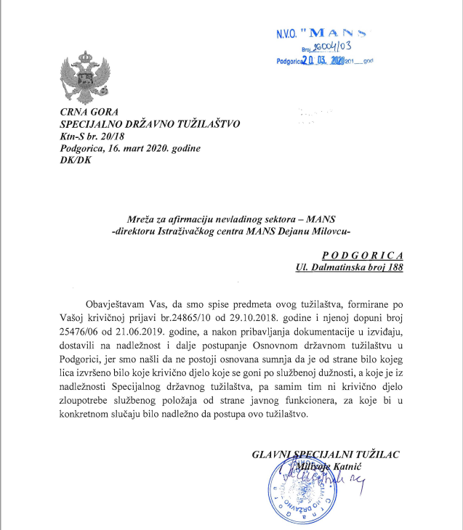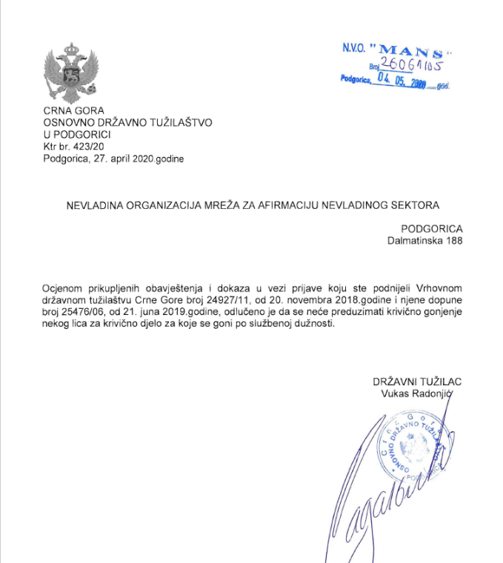

See more at: https://www.mans.co.me/da-li-ce-rijeka-tara-prezivjeti-izgradnju-auto-puta/
Articles 303, 307, 310 and 416 of the Criminal Code of Montenegro (Official Gazette of Montenegro no. 70/2003, 13/2004 - amended and 47/2006 and "Official Gazette of Montenegro", no. 40/2008, 25 / 2010, 32/2011, 64/2011 - other law, 40/2013, 56/2013 - amended, 14/2015, 42/2015, 58/2015 - other law, 44/2017, 49/2018 and 3 / 2020)
p. 355 Environmental Impact Assessment Study for the construction of the highway Bar - Boljare, section Smokovac - Mateševo
Criminal complaint of the NGO MANS, Green Home, Montenegrin Ecologists Society (CDE), Center for Protection and Research of Birds (CZIP), Expeditio and Our Action no. 24865/10 of 29 October 2018. See more at: https://www.mans.co.me/mans-u-saradnji-sa-ekoloskim-organizacijama-podnio-krivicnu-prijavu-zbog-devastacije-rijeke-tare/ and https://www.vijesti.me/vijesti/podnijete-krivicne-prijave-zbog-devastacije-tare
Document of the Supreme State Prosecutor's Office no. 157/18 of 31 October 2018
EP resolution on Montenegro: https://www.europarl.europa.eu/doceo/document/TA-8-2018-0482_EN.html
EU Report on Montenegro: https://ec.europa.eu/neighbourhood-enlargement/sites/near/files/20190529-montenegro-report.pdf
See more at: https://whc.unesco.org/en/documents/174707 i https://whc.unesco.org/archive/2019/whc19-43com-18-en.pdf
See more at: http://www.mans.co.me/deponije-na-tari-udvostrucene-uprkos-porukama-iz-eu/
Amendment to criminal complaint no. 25476/06 of 21 June 2019
Special State Prosecutor's Office's response no. 20/18 of 16 March 2020
Decision of the Basic State Prosecutor's Office no. 423/20 of 27 April 2020.
Complaint of NGO MANS no. 26065/05 of 8 May 2020

